**MEMT 201 Section 001**

Instructor: Dr. Prabhu Arumugam

**HW #2 (Due: 4/3/19)**

1. Calculate the number of vacancies per cubic meter in gold (Au) at 900°C. The energy for vacancy formation is 0.98 eV/atom. Furthermore, the density and atomic weight for Au are 18.63 g/cm3 and 196.9 g/mol, respectively.

**Given:**

* T = 900°C
* Qv = 0.98 eV/atom
* The properties of gold

**Required:**

* Number of vacancies, Nv

**Solution:**

Determine the number of lattice sites:

$N=\frac{N_{A}ρ}{A_{Au}}=\frac{\left(6.022∙{10}^{23} \frac{sites}{mol}\right)\left(18.63 \frac{g}{{cm}^{3}}\right)}{196.9 \frac{g}{mol}}\left(\frac{{10}^{6}{cm}^{3}}{m^{3}}\right)=5.697∙{10}^{28}$

Determine equilibrium vacancy concentration:

$N_{V}=N∙\exp\left(\frac{-Q_{v}}{kT}\right)=N∙\exp\left(\frac{-0.98 \frac{eV}{atom}}{\left(8.62∙{10}^{-5} \frac{eV}{atom-K}\right)\left(900+273 K\right)}\right)=N(6.17∙{10}^{-5})$

Determine the number of vacancies:

$N\left(6.17∙{10}^{-5}\right)=\left(5.697∙{10}^{28} \frac{sites}{m^{3}}\right)\left(6.17∙{10}^{-5}\right)=3.52∙{10}^{24}m^{-3}$

1. A specimen of copper having a rectangular cross section 15.2 mm × 19.1 mm is pulled in tension with 44,500 N, producing only elastic deformation. Calculate the resulting strain.

**Given:**

* Area = 15.2 mm x 19.1 mm = 2.9032 m2
* Force = 44500 N
* Using copper

**Required:**

* Strain

**Solution:**

Calculate the stress in the specimen:

$σ=\frac{F}{A}=\frac{44500 N}{2.9032 m^{2}}=153.28∙{10}^{6} \frac{N}{m^{2}}$

The modulus of elasticity of copper at room temperature is 110 * 109 N/m2

Calculate the strain:

$ε=\frac{σ}{E_{cu}}=\frac{153.28∙{10}^{6} \frac{N}{m^{2}}}{110∙{10}^{9}\frac{N}{{ m}^{2}}}=1.3935∙{10}^{-3}$

1. An aluminum bar 125 mm long and having a square cross section 16.5 mm on an edge is pulled in tension with a load of 66,700 N and experiences an elongation of 0.43 mm. Assuming that the deformation is entirely elastic, calculate the modulus of elasticity of the aluminum.

**Given:**

* Length = 125 mm
* Edge length = 16.5 mm
* Force = 66700 N
* Elongation = 0.43 mm

**Required:**

* Modulus of Elasticity

**Solution:**

Obtain area of cross section:

$A=l*l={\left(16.5 mm\right)}^{2}={272.25 mm}^{2}=2.72∙{10}^{-4} m^{2}$

Calculate the stress in the bar:

$σ=\frac{F}{A}=\frac{66700 N}{2.72∙{10}^{-4} m^{2}}=245.22∙{10}^{6} \frac{N}{m^{2}}$

Calculate the strain:

$ε=\frac{∆L}{L}=\frac{0.43 mm}{125 mm}=3.44∙{10}^{-3}$

Calculate the modulus of elasticity:

$E=\frac{σ}{ε}=\frac{245.22∙{10}^{6} \frac{N}{m^{2}}}{3.44∙{10}^{-3}}=71.28∙{10}^{9}\frac{N}{m^{2}}=71.28 GPa$

1. The following figure shows the tensile stress-strain curve for a plain-carbon steel.

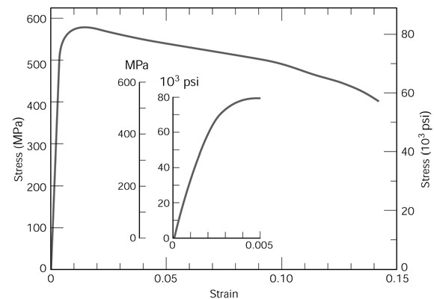

(a) What is this alloy’s tensile strength?

1. 650 MPa **(C) 570 MPa**
2. 300 MPa (D) 3,000 MPa

(b) What is its modulus of elasticity?

1. 320 GPa (C) 500 GPa
2. 400 GPa **(D) 215 GPa**

(c) What is the yield strength?

1. **550 MPa** (C) 600 MPa
2. 420 MPa (D) 1000 MPa
   1. Plastically deforming a metal specimen near room temperature generally leads to which of the following property changes?

* + 1. **An increased tensile strength and a decreased ductility**
    2. A decreased tensile strength and an increased ductility
    3. An increased tensile strength and an increased ductility
    4. A decreased tensile strength and a decreased ductility
  1. A steel rod is pulled in tension with a stress that is less than the yield strength. The modulus of elasticity may be calculated as
     1. **Axial stress divided by axial strain**
     2. Axial stress divided by change in length
     3. Axial stress times axial strain
     4. Axial load divided by change in length

* 1. A dislocation formed by adding an extra half-plane of atoms to a crystal is referred to as a (an)
     1. screw dislocation
     2. vacancy dislocation
     3. interstitial dislocation
     4. **edge dislocation**